**NAME: Ahtisham Bin Maqsood**

**ROLL No: 055**

**SECTION: 3A**

**LAB 10**

**Stack using Array:**

1. **Push** – Add an element to the top of the stack by placing it at the next available index in the array and incrementing the top pointer.
2. **Pop** – Remove the top element by accessing the current top index, retrieving the value, and then decrementing the top pointer.
3. **Display** – Traverse the array from the top pointer down to index 0 to show all stack elements in LIFO (Last In, First Out) order.

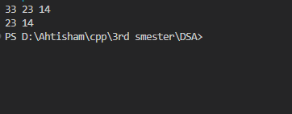

**Stack using Linked List:**

1. **Push** – Create a new node and insert it at the beginning (head) of the linked list; this new node becomes the new top of the stack.
2. **Pop** – Remove the top element by deleting the head node and updating the head pointer to the next node.
3. **Display** – Traverse the linked list from the head, printing each node's value to display stack elements in LIFO order.

